Date: 13/04/2020
Sem 2
Subject: Human Resource Management
Topic: Training and Development
Training is teaching, or developing in oneself or others, any skills and knowledge or fitness that relate to specific useful competencies. Training has specific goals of improving one's capability, capacity, productivity and performance. It forms the core of apprenticeships and provides the backbone of content at institutes of technology. In addition to the basic training required for a trade, occupation or profession, training may continue beyond initial competence to maintain, upgrade and update skills throughout working life. People within some professions and occupations may refer to this sort of training as professional development. Training also refers to the development of physical fitness related to a specific competence, such as sport, martial arts, military applications and some other occupations.
Training is about knowing where you are in the present and after some time where will you reach with your abilities. By training, people can learn new information, new methodology and refresh their existing knowledge and skills. Due to this there is much improvement and adds up the effectiveness at work. The motive behind giving the training is to create an impact that lasts beyond the end time of the training itself and employee gets updated with the new phenomenon. Training can be offered as skill development for individuals and groups.
Organizational Development is a process that “strives to build the capacity to achieve and sustain a new desired state that benefits the organization or community and the world around them.”
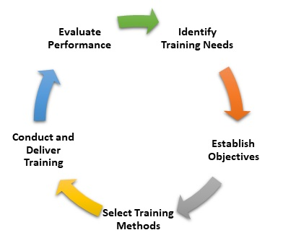

Relation between Training and Development
There is a relation between training and development, and there is clear difference between the two based on goals to be achieved. Development is made to answer the training problems:
TRAINING | DEVELOPMENT
Training is meant for operatives | Development is meant for executives
It is reactive process | It is pro- active process
AIM: To develop additional skills | AIM: To develop the total personality
It is short term process | It is continuous process
OBJECTIVE: To meet the present need of an employee | OBJECTIVE: To meet the future need of an employee
Initiative is taken by the management | Initiative is taken by an individual.

Importance of Training and Development
For companies to keep improving, it is important for organizations to have continuous training and development programs for their employees. Competition and the business environment keeps changing, and hence it is critical to keep learning and pick up new skills. The importance of training and development is as follows:
• Optimum utilization of Human resources
• Development of skills like time management, leadership, team management etc
• To increase the productivity and enhance employee motivation
• To provide the zeal of team spirit
• For improvement of organization culture
• To improve quality, safety
• To increase profitability
• Improve the morale and corporate image

Need for Training and Development
Training and development of employees is a costly activity as it requires a lot quality inputs from trainers as well as employees. But it is essential that the company revises its goals and efficiencies with the changing environment. Here are a few critical reasons why the company endorses training and development sessions.
• When management thinks that there is a need to improve the performances of employees
• To set up the benchmark of improvement so far in the performance improvement effort
• To train about the specific job responsibility and skills like communication management, team management etc
• To test the new methodology for increasing the productivity

Advantages of training and development
Training and development has a cost attached to it. However, since it is beneficial for companies in the long run, they ensure employees are trained regularly. Some advantages are:
1. Helps employees develop new skills and increases their knowledge.
2. Improves efficiency and productivity of the individuals as well as the teams.
3. Proper training and development can remove bottle-necks in operations.
4. New & improved job positions can be created to make the organization leaner.
5. Keeps employees motivated and refreshes their goals, ambitions and contribution levels.

Disadvantages of training and development
Even though there are several advantages, some drawbacks of training and development are mentioned below:
1. It is an expensive process which includes arranging the correct trainers and engaging employees for non-revenue activities.
2. There is a risk that after the training and development session, the employee can quit the job.

Training and Development Process
Training and development is a continuous process as the skills, knowledge and quality of work needs constant improvement. Since businesses are changing rapidly, it is critical that companies focus on training their employees after constantly monitoring them & developing their overall personality.
Steps for training and development processes are:
1. Determine the need of training and development for individuals or teams
2. Establish specific objectives & goals which need to be achieved
3. Select the methods of training
4. Conduct and implement the programs for employees
5. Evaluate the output and performance post the training and development sessions.
6. Keep monitoring and evaluating the performances and again see if more training is required.

